**What the paper contributes to knowledge?**

* We present a CFD-MPM model that simulates the entire process of submarine landslides.
* Our research highlights the critical role of permeability: (1) Slower dissipation of excess pore water pressure leads to an increase in the debris runout. (2) Permeability also governs the failure mechanism of submarine landslides in different sediment types. Lowering permeability triggers a transition from a sand flow slide to a clay spreading mechanism.

**What evidence the paper created to support the contribution claims?**

The model is validated based on centrifuge experiments of earthquake induced submarine landslides.

**What is particular novel about the insights generated in the research?**

Unlike other current model in literature, our model (1) incorporates effective stress analysis, providing a comprehensive understanding of triggering mechanisms and excess pore water pressure development and (2) offers unique capabilities for exploring earthquake-induced submarine landslides with exceptional detail and accuracy.

**Why the contributions matter? (What problems are addressed / What opportunities are created)**

For landslide risk assessment

**What the limitations of the research are?**

Constitutive model is not the best option for cyclic behavior of soil.

**What next steps are suggested?**

New constitutive model for cyclic loading.

.

**Mechanism of Earthquake-Induced Submarine Landslides and the Influence of Sediment Permeability: Centrifuge Validation and CFD-MPM Analysis**

Quoc-Anh Tran1, Erik Sørlie1, Gustav Grimstad1, Gudmund Eiksund1, Hidenori Takahashi2, Shinji Sassa2

1 Department of Civil and Environmental Engineering, Norwegian University of Science and Technology, Norway.

2 Port and Airport Research Institute, National Institute of Maritime, Port and Aviation Technology, Yokosuka, Japan.

ABSTRACT

Seismic induced submarine landslides pose a significant risk to offshore structures. To better understand this phenomenon, we have developed a CFD-MPM model that allows us to simulate the complete seismic induced submarine landslide mechanism. Recent centrifuge experiments have demonstrated that the permeability of marine sediment is a critical factor in determining the failure mechanism of submarine landslides. Specifically, reducing permeability can trigger a change from slope failure to debris flow. Our CFD-MPM model has been validated with these experiments and confirms this finding. Moreover, we conducted a sensitivity analysis of the seismic induced submarine landslide mechanism using our model. We found that lower permeability leads to slow dissipation of excess pore water pressure, resulting in longer run-out of submarine debris flow. Furthermore, reducing permeability triggers a change in failure mechanism from sand flow slide to clay spreading, which resembles real-life observations. This study provides insights into the influence of sediment permeability on the mechanism of submarine landslides, which is crucial for hazard assessment and mitigation strategies in offshore engineering and coastal management.

KEYWORKS: earthquakes, submarine landslides, coupled Material Point Method and Computational Fluid Dynamics, large deformation modeling.

# Introduction

Submarine landslides present a significant risk to offshore and nearshore structures, encompassing the potential for substantial impact forces, seabed entrainment, and tsunamis (Harbitz et al., 2014; Locat & Lee, 2002; Puzrin, 2016). Recent catastrophic events, such as the 2018 Indonesia Sulawesi earthquake and tsunami disasters, have underscored the importance of earthquake-induced submarine landslides and their profound consequences. These disasters involved a powerful strike-slip fault earthquake inducing extensive liquefaction along coastal areas, leading to numerous coastal and submarine landslides and subsequent tsunamis (Sassa & Takagawa, 2019). The resulting cascading effects caused over 2000 fatalities, with the collapsed areas being approximately ten times larger than those observed in the 2010 Haiti earthquake, which shared similar fundamental mechanisms of a strike-slip fault earthquake, liquefaction, coastal and submarine landslides, and tsunamis. These events emphasize the complex and interconnected physics of multiple geohazards (Sassa & Takagawa, 2019).

The process of earthquake-induced submarine landslides involves two distinct stages: pre-failure and post-failure. In the pre-failure stage, seismic activity triggers slope failure, leading to the subsequent rapid movement of sediments in the post-failure stage. In general, engineers assess the submarine landslide risk by separately analyzing these stages. Finite element analysis is used to evaluate the pre-failure stage by computing safety factors for high-risk areas prone to seismic activity. Then, Computational Fluid Dynamics (CFD) is employed to assess the consequences of the submarine landslides in the post-failure stage. Even though CFD has limitations including to know the amount of soil released and the mechanism in advance, simulating the complete process of a submarine landslide is challenging due to the transition from solid-like to fluid-like behavior of seabed slopes.

This paper presents a coupled Computational Fluid Dynamics – Material Point Method (CFD-MPM) model capable of simulating the complete process of a submarine landslide. Unlike previous models that rely on total stress analysis (e.g., Material Point Method (Shi et al., 2020), Smooth Particle Hydro Dynamics (Capone et al., 2010), Particle Finite Element Method (Zhang et al., 2019), or Coupled Eulerian Lagrangian method (Dey et al., 2016)), the CFD-MPM model (Tran et al., 2022) incorporates effective stress analysis, providing a more comprehensive understanding of the triggering mechanisms and excess pore water pressure in both the pre-failure and post-failure stages. Furthermore, the study emphasizes the importance of considering the dynamics of submarine liquefied flows including a phase change process where the transient fluid-like sediment re-establishes a solid framework supported by grains. This process is accompanied by the migration of pore fluids during flowage (Sassa & Sekiguchi, 2010, 2012). The integration of fluid dynamics and soil mechanics is crucial for predicting the concurrent processes of these flows, including flow stratification and redeposition. These processes are governed by the fundamental principles of two-phase physics, observed from laboratory to field settings (Sassa & Sekiguchi, 2010, 2012). In this study, we specifically address and elucidate the influence of sediment permeability across the entire spectrum of submarine landslides, ranging from sand to clay, using the CFD-MPM model developed herein.

To validate the present model, geotechnical centrifuge experiments were conducted to simulate earthquake-induced submarine landslides at the Port and Airport Research Institute in Japan. The experiments emphasized the importance of permeability in the transition from slope failure to gravity debris flows. Slowing the dissipation of excess pore water pressure proved crucial for generating gravity flows, while liquefaction induced solely by seismic loading was insufficient to generate long runouts of submarine debris flows (Takahashi et al., 2020). The numerical model successfully captured this transition and replicated the observed development of excess water pressure. Building on this validation, we investigate the influence of permeability on the failure mechanism of submarine landslides. We found that permeability plays a key role in determining the failure mechanisms, particularly in differentiating between sand and clay slopes. Integrating validated CFD-MPM model with centrifuge experiments yielded two key findings. Firstly, permeability was found to critically influence the runout behavior of submarine debris flows. Both experiment and numerical results demonstrated that slower dissipation of excess pore water pressure significantly increase the extent of runout. Secondly, our study revealed that permeability governs the failure mechanism of submarine landslides in different sediment types. Reducing permeability triggers a transition from a sand flow slide to a spreading mechanism. This finding provides valuable insights into the complex behavior of marine sediments under seismic disturbances and emphasizes the need to consider permeability as one of the fundamental parameters in comprehensive modeling approaches.

# Coupled CFD-MPM Model

A comprehensive description of the methods, including algorithms, differential equations, numerical development, implementation, and validation, can be found in the detailed work by Tran et al. (Tran et al., 2023). To avoid repetition, in this section, we only provide a brief overview of the coupled CFD-MPM model's key features.

The coupled Computational Fluid Dynamics-Material Point Method (CFD-MPM) approach integrates the capabilities of both methods to effectively simulate earthquake-induced submarine landslides. The Material Point Method (MPM) is employed to handle large deformations in porous media, specifically for modeling the behavior of the seabed and debris flows. In the MPM component, soil constitutive models can be defined, which are crucial for capturing the initiation mechanism of the flow. The interaction between solids represented by MPM materials is governed by contact laws such as Coulomb's friction.

On the other hand, Computational Fluid Dynamics (CFD) is utilized to analyze fluid dynamics, including the movement of water and air. CFD is a widely adopted method for simulating complex viscous fluid flows involving turbulence and hydroplaning, such as when debris flows lose friction with the seabed. By using CFD, the numerical instability of water pressure can be avoided, which would require additional numerical treatments in MPM, such as the B-bar method (Bandara & Soga, 2015), null-space filter (Tran & Sołowski, 2019), or least square approximation (Tran, Berzins, et al., 2019; Tran, Wobbes, et al., 2019; Zheng et al., 2021).

Overall, the CFD-MPM model provides a comprehensive framework for capturing the intricate mechanisms involved in earthquake-induced submarine landslides, accounting for solid-fluid interactions. This approach allows for a detailed analysis of the phenomenon, considering the complex behavior of solids and fluids in a unified simulation environment.

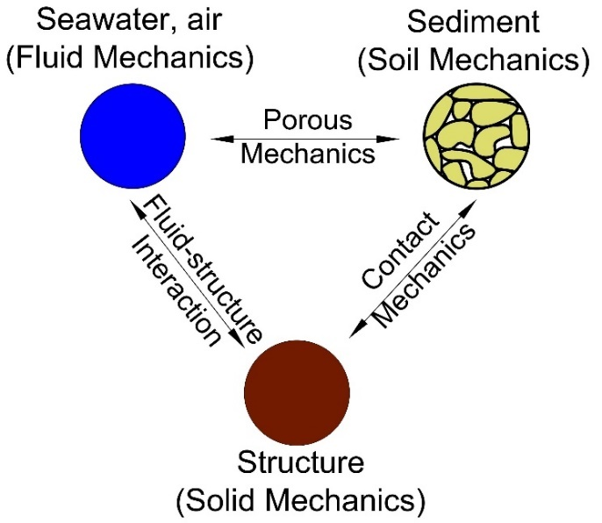

Figure 1 Schematic of the soil-water-structure interaction

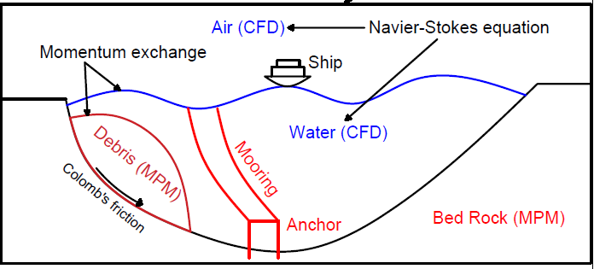

Figure 2 Schematic of the MPMICE model

The CFD component is based on the implicit continuous-fluid Eulerian (ICE) method, where all state variables are located at the cell/body centers. These variables, represented as the material vector ($M_{f}$, $u_{f}$, $p$, ${}_{f}$, $v_{f}$), encompass mass, velocity, pressure, volume fraction, and specific volume. The MPM approach utilizes the generalized interpolation technique (Bardenhagen & Kober, 2004) that has been validated through laboratory experiments (Tran et al., 2017a; Tran et al., 2017b) and large-scale landslide simulations (Tran & Solowski, 2019). To couple the MPM method with ICE, the state variables of the MPM material points, including mass, velocity, and effective stress ($M_{s}$, $u_{s}$, ${}^{'}$), are mapped to the cell centers using the generalized interpolation technique. Subsequently, the governing equations are solved on the Eulerian background mesh as below:

*Mass Balance Equation*

|  |  |  |
| --- | --- | --- |
|  | $$\frac{1}{V}\frac{D_{r}M_{r}}{Dt}=0$$ | (1) |

*Momentum Balance Equation for fluid*

|  |  |  |
| --- | --- | --- |
|  | $$\frac{1}{V}\frac{D_{f}\left(M_{f}u_{f}\right)}{Dt}=-{}_{f}p+{}_{f}{}_{f}g+\sum{f_{d}}$$ | (2) |

*Momentum Balance Equation for solid*

|  |  |  |
| --- | --- | --- |
|  | $$\frac{1}{V}\frac{D_{s}\left(M_{s}u_{s}\right)}{Dt}=.{}^{'}-{}_{s}p+{}_{s}{}_{s}g-\sum{f_{d}}$$ | (3) |

The last term is the momentum exchange between materials $f_{d}$. Apart from mass and momentum balance equations, coupled CFD-MPM also solves the energy balance equations (not presented here in), all implicitly. However, we set the numerical simulations in the isothermal condition (no thermal expansion and conduction effect) for the sake of simplicity. This is also combined with the generalized Poisson’s equation to compute the fluid pressure for compressible fluid materials.

## *Momentum Exchange*

For the momentum exchange, we assume that $f_{d}$ (Beetstra et al., 2007) is given by:

|  |  |  |
| --- | --- | --- |
|  | $$f_{d}=\frac{18{}_{s}\left(1-{}_{s}\right){}_{f}}{D_{p}^{2}}F({}_{s},Re)(u_{s}-u_{f})$$ | (4) |

where $D_{p}$ is the average grain size of the grains, the solid volume fraction is ${}_{s}$, the fluid viscosity is ${}_{f}$, the relative velocities of soil grains and fluid is $(u_{s}-u_{f})$ and Re is the Reynolds number which is calculated as:

|  |  |  |
| --- | --- | --- |
|  |  | (5) |

The function $F\left({}_{s},Re\right)$ is given as:

|  |  |
| --- | --- |
| $$F\left({}_{s},Re\right)= F\left({}_{s},0\right)+\frac{0.413Re}{24{\left(1-{}_{s}\right)}^{2}} \frac{{\left(1-{}_{s}\right)}^{-1}+3{}_{s}\left(1-{}_{s}\right)+8.4{Re}^{-0.343}}{1+{10}^{3{}_{s}}{Re}^{-(1+4{}_{s})/2}}$$ | (6) |

where the low Reynold coefficient $F\left({}_{s},0\right)$ is:

|  |  |
| --- | --- |
| $$F\left({}_{s},0\right)=\frac{10}{{\left(1-{}_{s}\right)}^{2}} +{\left(1-{}_{s}\right)}^{2}(1+1.5\sqrt{{}_{s})}$$ | (7) |

The permeability implicitly depends on the size of the soil grain $D_{p}$, the viscosity of the fluid ${}_{f}$, and the porosity $\left(1-{}_{s}\right)$.

## *Soil Models*

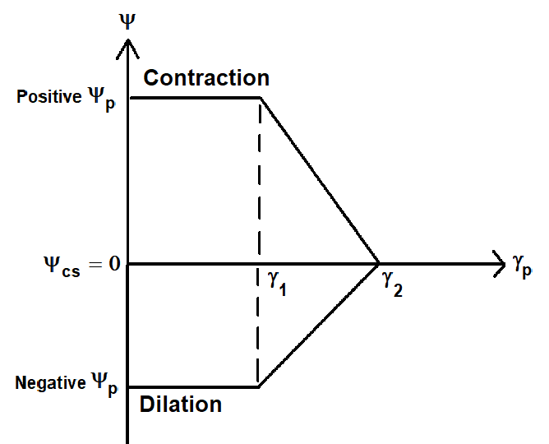

Figure 3 Evolution of the dilatancy angle model

In the numerical examples, a non-associated Mohr-Coulomb model is employed. Through sensitivity analysis, it has been determined that the Young's modulus has negligible impact on the simulations, where plastic deformation dominates. Therefore, Young's modulus is set to be 10 kPa and Poisson's ratio is 0.3 with zero cohesion for all simulations. The plasticity model incorporates mobilized friction angle ${}_{m}^{ '}$, critical state friction angle ${}_{cs}^{ '}$ and mobilized dilatancy angle ${}_{m}^{ '}$. To capture the critical state behavior of the soil, the evolution of the mobilized dilatancy angle is controlled by four parameters: peak dilatancy angle ${}_{p}^{ '}$, critical state dilatancy angle ${}_{cs}^{ '}=0$, plastic shear strain $γ_{1}^{ }$, $γ_{2}^{ }$. The mobilized friction angle is calculated based on Rowe’s stress dilatancy theory (Wood, 1990) using the following relationship:

|  |  |  |
| --- | --- | --- |
|  | $$\sin{{}_{m}^{ '}}=\frac{\sin{{}_{m}^{ '}}+\sin{{}_{cs}^{ '}}}{1+ \sin{{}_{cs}^{ '}}\sin{{}_{m}^{ '}}}$$ | (8) |

## *Fluid equation of state models*

The equation of state establishes relations between thermodynamics variables. For the air, the equation of state for the perfect gas is adopted while for the water, a simple linear equation of state can be written as:

|  |  |  |
| --- | --- | --- |
|  | $$P_{f}=P_{ref}+K_{f}({}_{f}-{}_{ref}+{}_{f}\left(T_{f}-T_{ref}\right))$$ | (9) |

where reference pressure $P_{ref}$ = 1 atm = 101325 Pa, reference temperature $T_{ref}$ = 10 °C, reference density ${}_{ref}$ = 9.998 kN/m3, the bulk modulus of water $K_{f}$ = 2 GPa, and the water thermal expansion = 0.18 °C-1. This equation matches well with the state of the water.

# Validation of the geotechnical centrifuge model test

## Brief description of the geotechnical centrifuge model test

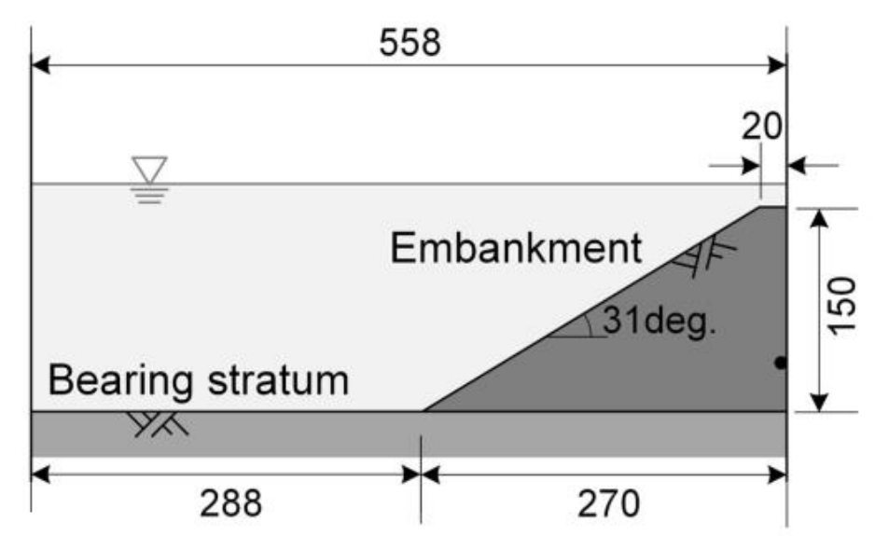

Figure 4 Setup of the geotechnical centrifuge experiment of the earthquake induced submarine landslides (Takahashi et al., 2020)

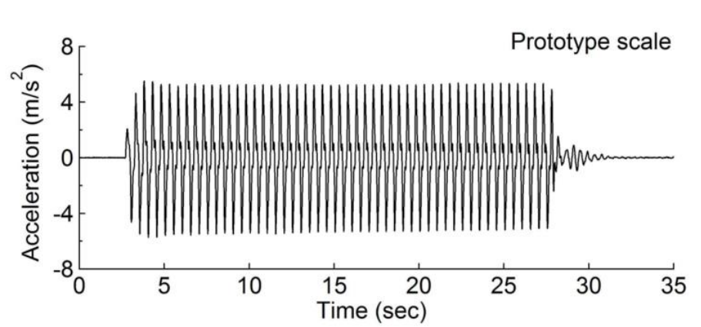

Figure 5 Seismic wave profile of the prototype scale (Takahashi et al., 2020)

This study attempted to reproduce the results of centrifuge model test conducted by the authors (Takahashi et al., 2020). In the model test, they succeeded, for the first time, in replicating the high-speed flow of debris during a submarine landslide. Liquefaction of the ground in a centrifugal field is typically achieved using a viscous fluid as pore water to delay the dissipation of excess pore water pressure. This technique can match the time similarity ratios between the dynamic behaviour and the propagation of the pore water pressure and liquefy the ground. However, this viscous scaling increases the apparent viscosity of the soil in the liquefied state, which slows down the movement of the liquefied soil. (Takahashi et al., 2016) proposed a method called fine-grain scaling in which water is used as the pore water, but pore water pressure propagation is delayed by mixing fine grains with the sand. This technique was applied to model tests on submarine landslides to reproduce the high-velocity flow of debris.

Various model tests have been conducted, but the cross-section shown in Figure 4 (Case KsL1 and KcL1) was replicated in this study. A soil mixture of kaolin clay (a mixture of silt and clay) and silica sand in the ratio of 4.8:95.2 for case KcL1 and 16.7:83.3 for case KcL1, with a relative density of 70%, was used to form a slope. This fine-grained content was adopted, as soil plasticity is more pronounced when the fine-grained content exceeds 20%. The test results showed that the higher the fine-grained content, the more fluid the soil became when liquefied. The ground was liquefied by applying the vibrations depicted in Figure 5 (converted to a prototype scale) to the prepared ground to replicate a submarine landslide. Consequently, the slope before the vibration, that is, the red line in Figure 6, instantly moved to the position of the blue line, and the slope collapsed. In case 1 (KsL1), the embankment only collapsed partially and there is no transition to the debris flow. On the other hand, in case 2 (KcL1), debris flow occurred at the top of the slope, with a velocity of approximately 1.0 m/s. Excess pore water pressure was observed during the model test, confirming that the ground was completely liquefied. The vibration caused the ground to liquefy and lose its strength, allowing the slope to collapse with debris flow.

|  |  |
| --- | --- |
|  |  |

Figure 6 Obervation from the centrifuge experiment, transition from initial slope (red line) to failure (blue line)

## Numerical validation

Numerical analysis was conducted to replicate an experimental study, where certain soil parameters such as porosity, density, and average grain size (Dp) were estimated based on laboratory tests. A soil constitutive model was assumed and calibrated through back analysis of the experimental results to capture the contractive behavior of the soil. Two numerical cases were performed, corresponding to two cases in the geotechnical centrifuge models. The initial stress condition is generated by running the simulations for 10 seconds with every high hydraulic conductivity (= 1m). The slope is fully consolidated after 10s under the gravity to create the initial effective stress and initial pore water pressure. We assumed during our study, specifically regarding the impact of clay content on the mechanical properties of the soil. It is assumed that increasing the clay content does not alter the mechanical properties, while the permeability of the soil decreases significantly. Therefore, in both numerical cases, the soil's mechanical properties remain the same, and the only difference lies in the soil permeability calculated from the grain size Dp.

Table 1. Contractive soil parameter used in the numerical validation.

|  |  |  |  |  |  |  |  |  |
| --- | --- | --- | --- | --- | --- | --- | --- | --- |
| **Test** | **% Clay** | **Density**  **ρs T/m3** | **Porosity**  **n** | **Grain size Dp** |  |  |  |  |
| Case 1 | 4.8 | 2.64 | 0.44 | 0.001 | 30 | -5 | 0.1 | 0.6 |
| Case 2 | 16.7 | 2.66 | 0.47 | 0.5 | 30 | -5 | 0.1 | 0.6 |

In Case 1, with a clay content of 4.8%, the numerical model predicts a partial slope failure that aligns with the experimental observations (as shown in Figure 7, displaying contour plots of pore water pressure). Following the cessation of seismic loading, Figure 8 demonstrates complete dissipation of the excess pore water pressure, facilitated by the high permeability of the soil (calculated from the average grain size Dp = 0.5 mm).

On the other hand, in Case 2, with a clay content of 16.7%, the numerical model predicts a transition from slope failure to gravity debris flow (refer to Figure 7). Figure 9 reveals that the excess pore water pressure was not fully dissipated due to the low permeability of the soil (calculated from the average grain size Dp = 0.001 mm).

In both cases, the numerical model exhibits satisfactory agreement in terms of the displacement of the slope toe with the centrifuge model (see Figure 10). Overall, the numerical model successfully replicates the transition from slope failure to debris flow and accurately reproduces the development of excess pore water pressure within the slope.

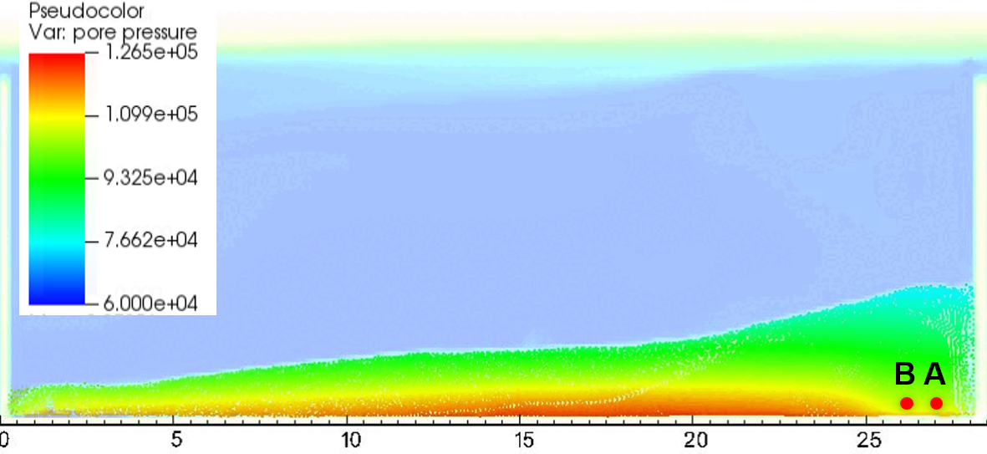





**Figure 7. Pore water pressure in Case 1**

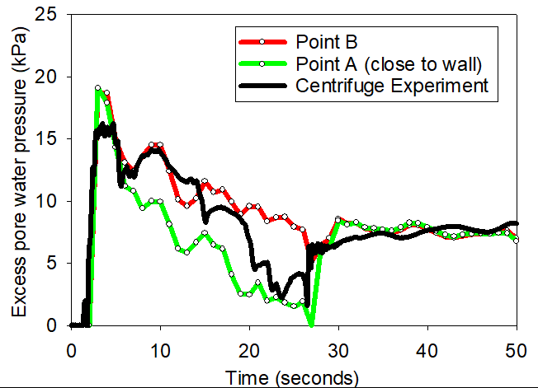

Figure 8. Development of the excess pore water pressure in Case 1



Figure 9. Development of the excess pore water pressure in Case 2

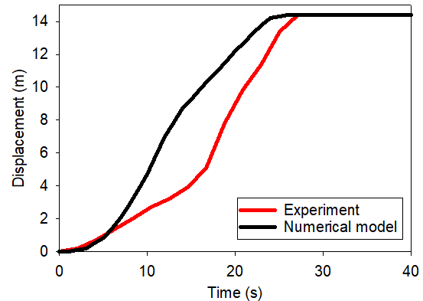

Figure 10. Displacement of the toe of the slope

# Influence of Permeability on the Failure Mechanism

In the previous section, we established that by solely manipulating the permeability while maintaining identical mechanical properties, the failure mechanisms of submarine slopes exhibit significant variation. Building upon these findings, this section aims to delve deeper into the mechanisms of earthquake-induced submarine landslides, specifically focusing on progressive failure, which could not be extensively studied due to limitations in the size of the soil box used in the geotechnical centrifuge experiments.

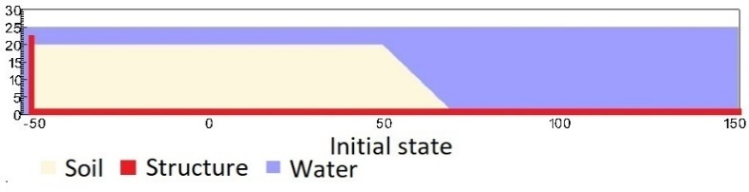

Figure 11. Geometry of the base case

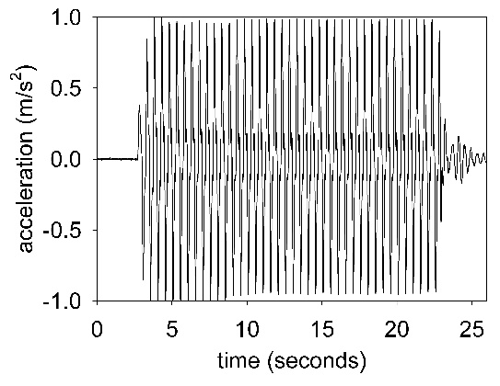

Figure 12. Ground acceleration profile, frequency of 2Hz and magnitude of 1g

To facilitate this investigation, we introduce a base case depicted in Figure 11. It comprises a 20-meter-high 100-meter-long slope with a 45-degree face confined within a horizontal and vertical structure resembling a plane box. This structure serves as a shaking table for the application of seismic loading. To simplify the seismic loading, we simulate ground shaking over a duration of 20 seconds, utilizing a peak ground acceleration of 1g and a frequency of 2 Hz (Figure 12). The contact between the horizontal plane and the soil is modeled as a frictional contact with a coefficient of friction set to 0.2. No artificial damping is imposed during the simulation. The contact between the vertical plane and the sand is assumed to be smooth. For the seawater, we consider a density of 9.98 kN/m3 at the water surface, under a pressure of 1 atm (101325 Pa) and a temperature of 10 °C. At the top boundary, the air density is 1.17 kg/m3, with a pressure of 1 atm. The viscosities of air and water at 10 degrees Celsius are 18.45e-3 mPa s and 1 mPa s, respectively. Symmetric boundary conditions are applied to all boundary faces, while the Neumann boundary conditions are imposed at the top boundary for pressure (dp/dx = 0 kPa) and density (dρ/dx = 0 kg/m3). The mesh size is set to 0.25 x 0.25m, resulting in 300,852 element cells and 142,316 material points. Throughout the simulations, we assume a constant temperature across the entire domain (isothermal condition), omitting thermal expansion and thermal conduction calculations. The initial stress condition is generated by running the simulations for 10 seconds with every high hydraulic conductivity (= 1m). The slope is fully consolidated after 10s under the gravity to create the initial effective stress and initial pore water pressure.

To emphasize the significance of permeability in determining the failure mechanisms of earthquake-induced submarine landslides, we analyse two cases: (4.1) Runout analysis employing the contractive soil parameters established in the previous section, successfully replicating the transition from slope failure to debris flow observed in the geotechnical centrifuge experiments, and (4.2) progressive failure analysis using dilative soil parameters.

## Runout analysis using contractive soil parameter.

We employed the contractive soil parameters (Case 1 for high permeability soil and Case 2 for low permeability soil) presented in Table 1 for the base case. The numerical analysis yielded the following observations:

* In Case 1, the seismic loading triggered slope failure, resulting in a runout distance of approximately 50 meters within 30 seconds. Notably, no shear band was observed during the slope failure, indicating the contractive behavior of the soil with a negative dilatancy angle (refer to Figure 13). Consistent with the geotechnical centrifuge model, the excess pore water pressure dissipated rapidly beneath the slope once the seismic loading ceased, causing the slope to come to a halt.

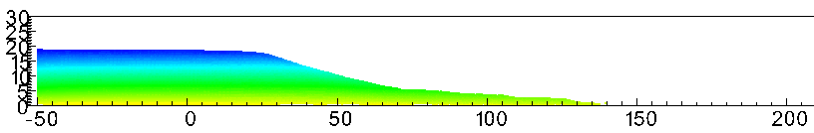

1. **Initial state**



1. **Simulation with soil parameter using high permeability (Case 1 in Table 1)**

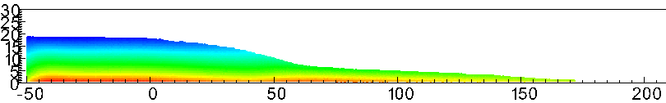

1. **Simulation with soil parameter using low permeability (Case 2 in Table 1)**

Figure 13. Influence of permeability, on top (a) the gravity debris flow stops running and, on the bottom, (b) the gravity debris flow still running due to slow dissipation of the excess pore water pressure.

* In Case 2, the seismic loading also led to slope failure, with a runout distance of around 100 meters within 30 seconds, surpassing the distance observed in Case 1 (see Figure 14). However, in contrast to Case 1, the excess pore water pressure did not fully dissipate beneath the slope after the seismic loading ended (refer to Figure 13). Consequently, the slope continued to move due to the sustained high excess pore water pressure.
* In case 2, the seismic loading triggered the failure of the slope, the run-out distance is about 100 m after 30 seconds, higher than in case 1 (see Figure 13). The excess pore water pressure is not fully dissipated in the underneath of the slope after the seismic loading ended (see Figure 13). The slope keeps running due to the high excess pore water pressure.

In summary, permeability was found to have a critical impact on the runout behavior of submarine debris flows. Both the experimental and numerical results highlighted the significance of slowing down the dissipation of excess pore water pressure for generating long runouts in submarine debris flows.

## Failure mechanism using dilative soil parameter.

## *Numerical soil parameters*

Two grain sizes are selected for the numerical analysis (1) $D_{p}$ = 0.5 mm and (2) $D_{p}$ = 0.0001 mm to mimic the permeability of sand and clay. We compare simulations with the same dilative soil parameters except for the grain size Dp (see Table 2). For both cases, we demonstrate the entire process and the mechanism of earthquake-induced submarine landslides and discuss to the differences in the mechanisms.

Table 2. Dilative soil parameter used in numerical examples

|  |  |  |  |  |  |  |  |
| --- | --- | --- | --- | --- | --- | --- | --- |
| **Test** | **Density**  **ρs T/m3** | **Porosity**  **n** | **Grain size Dp** |  |  |  |  |
| Case 1 | 2.65 | 0.3 | 0.0001 | 10 | 35 | 0.05 | 0.2 |
| Case 2 | 2.65 | 0.3 | 0.5 | 10 | 35 | 0.05 | 0.2 |

## *Retrogressive flow slide (high permeability soil)*

Due to the high permeability, the slope experienced immediate collapse following the initial seismic event, leading to a failure mechanism classified as a retrogressive flow slide according to the updated Varnes classification (Hungr et al., 2014). Field investigations have revealed that the retrogressive flow slide occurs due to two primary mechanisms: erosion at soil interfaces and retrogressive sliding of the slope (see Figure 14).

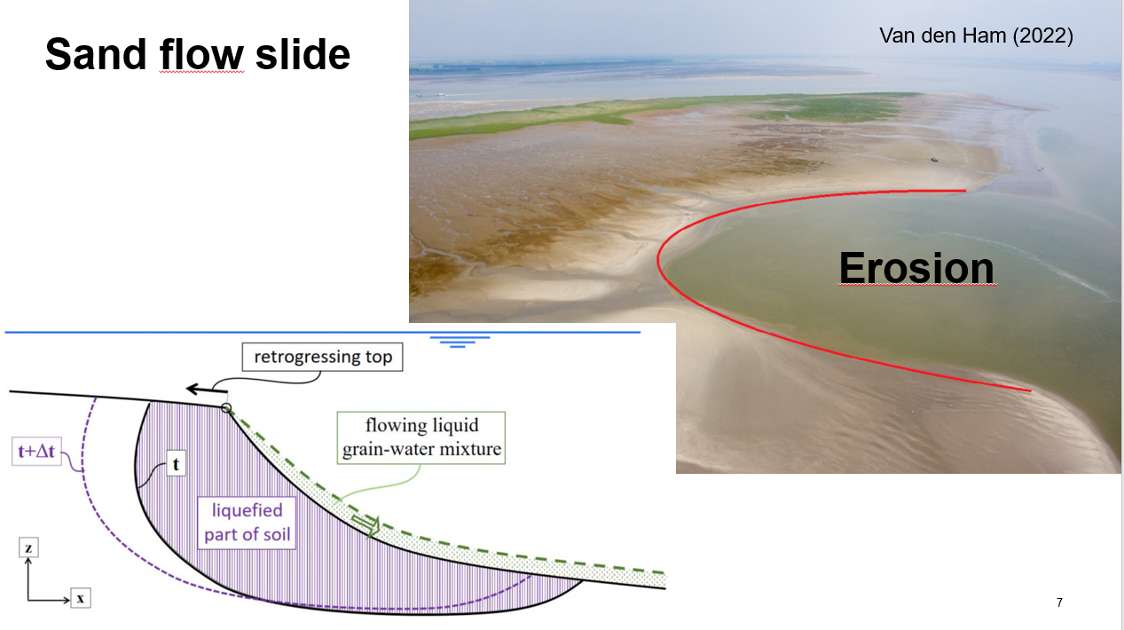

Figure 14. Sand flow slide mechanism (Ham et al., 2023)

By employing the coupled CFD-MPM model, we successfully replicated the process of the retrogressive flow slide in soils with high permeability (refer to Figure 15). During seismic loading, the slope undergoes erosion at the soil interfaces, followed by retrogressive sliding and debris flows. Notably, even after the seismic event concludes, erosion continues, gradually resulting in a lower slope gradient of approximately 10 degrees. It is worth emphasizing that the development of the shear band is rapid during shaking and persists at a slower rate after the shaking subsides. This phenomenon may be attributed to secondary effects induced by waves and turbulent flows. The generated slide wave is estimated to be approximately 2-3 meters in height. During landslide events, the excess water pressure exhibits slight changes during shaking. However, due to the high hydraulic conductivity of the soil, this pressure quickly returns to hydrostatic pressure during landslides (Figure 16).

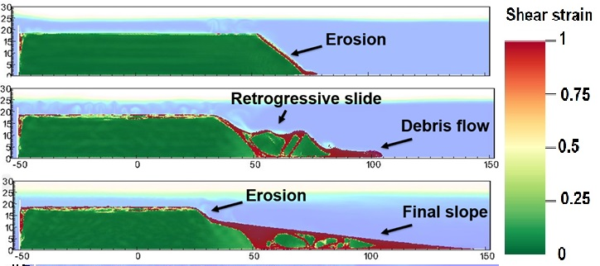

Figure 15. Simulation of retrogressive flow slide with shear strain

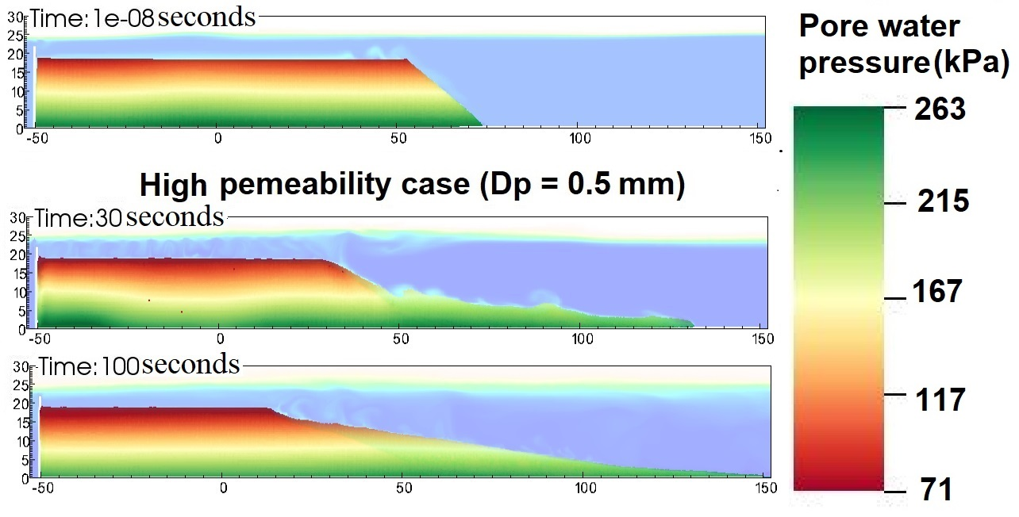

Figure 16. Simulation of retrogressive flow slide with total

*Clay spreads (low permeability soil)*

In the case of low permeability, similar to the previous scenario, the slope experienced immediate collapse following the initial seismic activity. This type of failure mechanism, known as spreads, according to the updated Varnes classification (Hungr et al., 2014), is commonly observed in submarine landslides in clay, including the notable Storegga slide, which is one of the largest known landslides in history. Spreading involves the fragmentation of sediment into smaller blocks called horsts and grabens, which are tilted and displaced along a sliding surface. The seafloor view provides a striking display of numerous soil blocks, while the seismic profile reveals the final deposition pattern of the Storegga slide (see Figure 1).

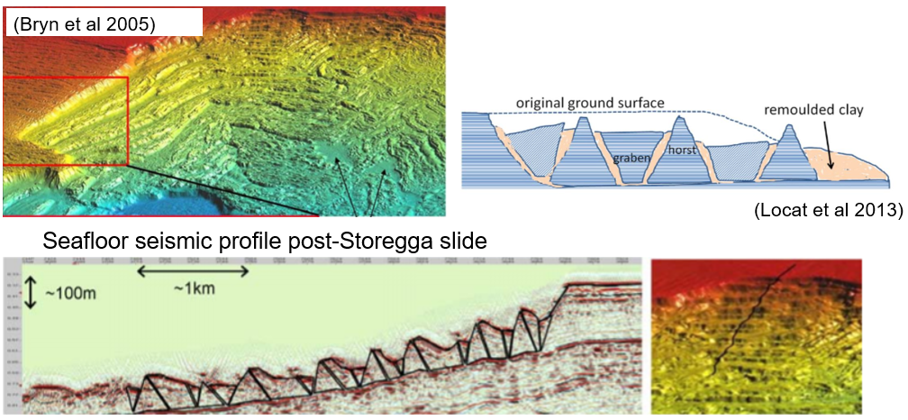

Figure 17. Clay spreads observed at the seabed near the Storegga slide (Bryn et al., 2005) and interpretation of clay spreads (Locat et al., 2013)

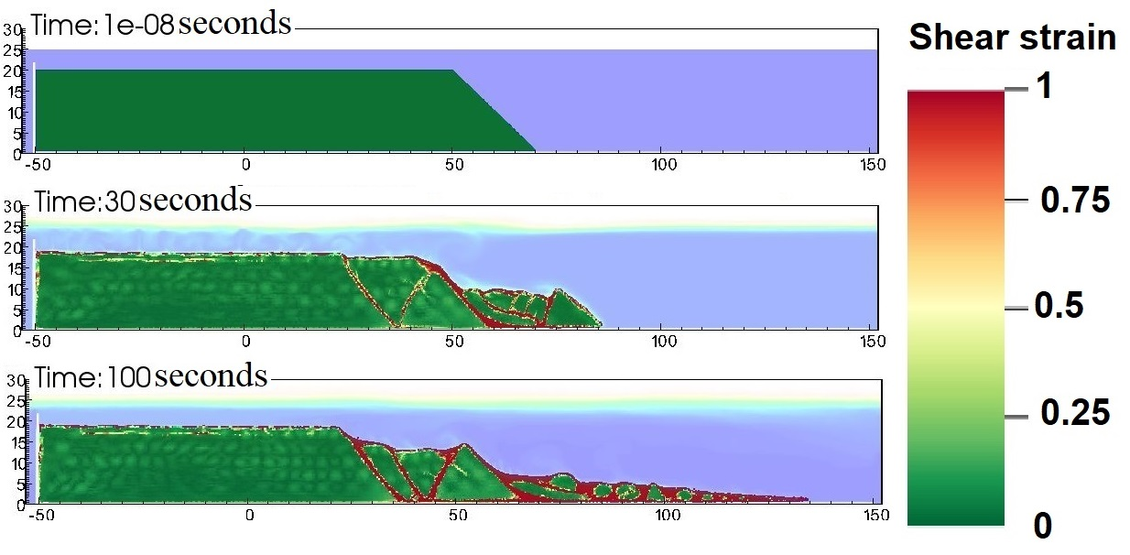

Figure 18. Simulation of clay spreads with shear strain

Using the coupled CFD-MPM model, we successfully replicated the process of clay spreads in soils with low permeability (see Figure 2). Our findings support the hypothesis that seismic loading can trigger this type of failure, lending further insight into the potential earthquake-induced triggering mechanism of the Storegga slide, which occurred approximately 8000 years ago.

Additionally, we demonstrate the advantages of employing effective stress analysis over total stress analysis when investigating the failure mechanism of undrained clay slides. One limitation of total stress analysis is that it predicted a simulated horst tip angle of around 90 degrees (Dey et al., 2016a; Tran & Solowski, 2019), whereas field observations indicated an angle of approximately 52 degrees (see Figure 7). However, based on our numerical results, the simulated horst tip angle is around 65 degrees (see Figure 5e), indicating a closer alignment with the field observations. Unlike the case of high hydraulic conductivity, the low permeability scenario exhibited a sharp increase in negative excess water pressure (Figure 6d) during the initiation of the shear band. Subsequently, the excess pore water pressure gradually dissipates, resulting in the slow run-out of debris materials that continue to move towards the right-hand boundary (Figure 6e).

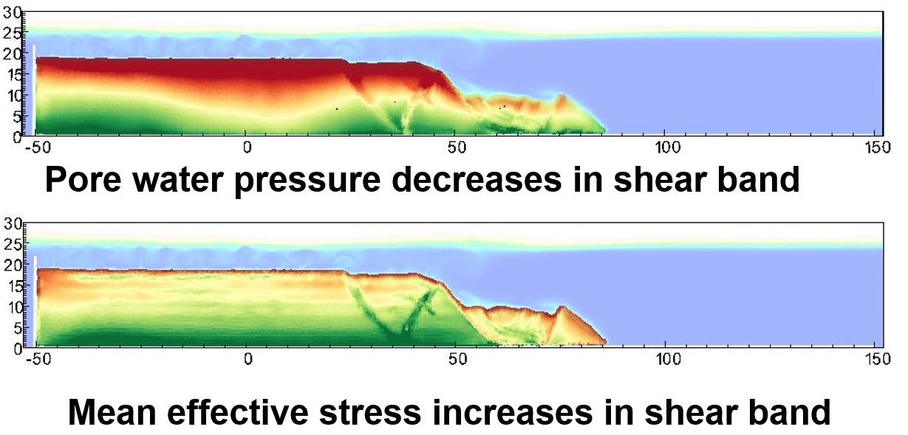

Figure 19. Soil dilation in the shear band

# Conclusion

Since a better integrated understanding of the multiple mechanisms and multi-phased physics of submarine landslides is important globally (Sassa et al., 2022), it is hoped that the findings and conclusions obtained in the present study may facilitate such a multi-disaster risk reduction from submarine landslides.

# Acknowledgements

The research received support from the European Union’s Horizon 2020 research and innovation program under the grant agreement 101022007. The computations were performed on High Performance Computing resources provided by UNINETT Sigma2 - the National Infrastructure for High Performance Computing and Data Storage in Norway. We would like to express our gratitude to the Soil Dynamics Group of the Port and Airport Research Institute in Yokosuka, Japan for their generous hospitality during our research visits in Japan.

# Code availability

Instructions for replicating the numerical results in this paper are given at the open-source platform GitHub (https://github.com/QuocAnh90/Uintah_NTNU). Also, the open-source code is shared in this platform for interested users to take up and make use of the results.

# Reference

Bandara, S., & Soga, K. (2015). Coupling of soil deformation and pore fluid flow using material point method (vol 663, pg 199, 2015). *Computers and Geotechnics*, *65*, 302-302. <https://doi.org/10.1016/j.compgeo.2014.12.007>

Bardenhagen, S. G., & Kober, E. M. (2004). The generalized interpolation material point method. *Cmes-Computer Modeling in Engineering & Sciences*, *5*(6), 477-495. <Go to ISI>://WOS:000222301300001

Beetstra, R., van der Hoef, M. A., & Kuipers, J. A. M. (2007). Drag force of intermediate Reynolds number flow past mono- and bidisperse arrays of spheres. *Aiche Journal*, *53*(2), 489-501. <https://doi.org/10.1002/aic.11065>

Bryn, P., Berg, K., Forsberg, C. F., Solheim, A., & Kvalstad, T. J. (2005). Explaining the Storegga Slide. *Marine and Petroleum Geology*, *22*(1-2), 11-19. <https://doi.org/10.1016/j.marpetgeo.2004.12.003>

Capone, T., Panizzo, A., & Monaghan, J. (2010). SPH modelling of water waves generated by submarine landslides. *Journal ofHydraulic Research*, *48*(1), 80-84.

Dey, R., Hawlader, C., Phillips, R., & Soga, K. (2016). Numerical modelling of submarine landslides with sensitive clay layers. *Géotechnique*, *66*(6), 454-468.

Ham, G. A. V., Groot, M. B. D., Mastbergen, D. R., & Berg, J. H. V. (2023). Breaching and liquefaction in subaqueous retrogressive flow slides. *Canadian Geotechnical Journal*, *60*(1), 72-85. <https://doi.org/10.1139/cgj-2021-0282>

Harbitz, C. B., Lovholt, F., & Bungum, H. (2014). Submarine landslide tsunamis: how extreme and how likely? *Natural Hazards*, *72*(3), 1341-1374. <https://doi.org/10.1007/s11069-013-0681-3>

Hungr, O., Leroueil, S., & Picarelli, L. (2014). The Varnes classification of landslide types, an update. *Landslides*, *11*(2), 167-194. <https://doi.org/10.1007/s10346-013-0436-y>

Locat, A., Jostad, H. P., & Leroueil, S. (2013). Numerical modeling of progressive failure and its implications for spreads in sensitive clays. *Canadian Geotechnical Journal*, *50*(9), 961-978. <https://doi.org/10.1139/cgj-2012-0390>

Locat, J., & Lee, H. J. (2002). Submarine landslides: advances and challenges. *Canadian Geotechnical Journal*, *39*(1), 193-212. <https://doi.org/10.1139/T01-089>

Puzrin, A. M. (2016). Simple criteria for ploughing and runout in post-failure evolution of submarine landslides. *Canadian Geotechnical Journal*, *53*(8), 1305-1314. <https://doi.org/10.1139/cgj-2015-0582>

Sassa, S., Grilli, S. T., Tappin, D. R., Sassa, K., Karnawati, D., Gusiakov, V. K., & Lovholt, F. (2022). Understanding and reducing the disaster risk of landslide-induced tsunamis: a short summary of the panel discussion in the World Tsunami Awareness Day Special Event of the Fifth World Landslide Forum. *Landslides*, *19*(2), 533-535. <https://doi.org/10.1007/s10346-021-01819-x>

Sassa, S., & Sekiguchi, H. (2010). Liqsedflow: Role of Two-Phase Physics in Subaqueous Sediment Gravity Flows. *Soils and Foundations*, *50*(4), 495-504. <https://doi.org/DOI> 10.3208/sandf.50.495

Sassa, S., & Sekiguchi, H. (2012). Dynamics of Submarine Liquefied Sediment Flows: Theory, Experiments and Analysis of Field Behavior. *Submarine Mass Movements and Their Consequences*, *31*, 405-+. <https://doi.org/10.1007/978-94-007-2162-3_36>

Sassa, S., & Takagawa, T. (2019). Liquefied gravity flow-induced tsunami: first evidence and comparison from the 2018 Indonesia Sulawesi earthquake and tsunami disasters. *Landslides*, *16*(1), 195-200. <https://doi.org/10.1007/s10346-018-1114-x>

Shi, J. J., Zhang, W., Wang, B., Li, C. Y., & Pan, B. (2020). Simulation of a Submarine Landslide Using the Coupled Material Point Method. *Mathematical Problems in Engineering*, *2020*. <https://doi.org/Artn> 4392581

10.1155/2020/4392581

Takahashi, H., Fujii, N., & Sassa, S. (2020). Centrifuge model tests of earthquake-induced submarine landslide. *International Journal of Physical Modelling in Geotechnics*, *20*(4), 254-266. <https://doi.org/10.1680/jphmg.18.00048>

Takahashi, H., Takahashi, N., Morikawa, Y., Towhata, I., & Takano, D. (2016). Efficacy of pile-type improvement against lateral flow of liquefied ground. *Geotechnique*, *66*(8), 617-626. <https://doi.org/10.1680/jgeot.14.P.238>

Tran, Q. A., Berzins, M., & Sołowski, W. (2019). An improved moving least squares method for the Material Point Method. International Conference on the Material Point Method for Modelling Soil-Water-Structure Interaction, Cambridge, UK.

Tran, Q. A., Grimstad, G., & Amiri, S. A. G. (2023). MPMICE: A hybrid MPM-CFD model for simulating coupled problems in porous media. Application to earthquake-induced submarine landslides. *arXiv preprint arXiv:2211.12761*.

Tran, Q. A., Grimstad, G., & Ghoreishian Amiri, S. A. (2022). MPMICE: A hybrid MPM-CFD model for simulating coupled problems in porous media. Application to earthquake-induced submarine landslides. *arXiv preprint*.

Tran, Q. A., & Solowski, W. (2019). Generalized Interpolation Material Point Method modelling of large deformation problems including strain-rate effects - Application to penetration and progressive failure problems. *Computers and Geotechnics*, *106*, 249-265. <https://doi.org/10.1016/j.compgeo.2018.10.020>

Tran, Q. A., & Sołowski, W. (2019). Temporal and null-space filter for the material point method. *International Journal for Numerical Methods in Engineering*, *120*(3), 328-360.

Tran, Q. A., Solowski, W., Karstunen, M., & Korkiala-Tanttu, L. (2017a). Modelling of fall-cone tests with strain-rate effects. *Proceedings of the 1st International Conference on the Material Point Method (Mpm 2017)*, *175*, 293-301. <https://doi.org/10.1016/j.proeng.2017.01.029>

Tran, Q. A., Solowski, W., Thakur, V., & Karstunen, M. (2017b). Modelling of the Quickness Test of Sensitive Clays Using the Generalized Interpolation Material Point Method. Landslides in Sensitive Clays. Advances in Natural and Technological Hazards Research,

Tran, Q. A., Wobbes, E. D., Sołowski, W., Moller, M., & Vuik, C. (2019). Moving least squares reconstruction for B-spline Material Point Method. International Conference on the Material Point Method for Modelling Soil-Water-Structure Interaction, Cambridge, UK.

Wood, D. (1990). *Soil Behaviour and Critical State Soil Mechanics*. Cambridge University Press. <https://doi.org/https://doi.org/10.1017/CBO9781139878272>

Zhang, X., Onate, E., Torres, S. A. G., Bleyer, J., & Krabbenhoft, K. (2019). A unified Lagrangian formulation for solid and fluid dynamics and its possibility for modelling submarine landslides and their consequences. *Computer methods in applied mechanics and engineering*, *343*, 314-338.

Zheng, X., Pisano, F., Vardon, P., & Hicks, M. A. (2021). An explicit stabilised material point method for coupled hydromechanical problems in two-phase porous media. *Computers and Geotechnics*, *135*, 104112.

**

*PWP*



Mean efffective stress

